

**Capstone Project Phase A**

Software Engineering Department, Braude College

25-2-D-21

Course 61999: Capstone Project in Software Engineering

**Pill Mate**

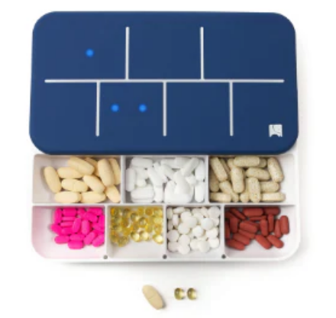

Mohamad Abo Ahmad – ID: 314934613 – Email: Mohammad.abu.ahmad@e.braude.ac.il

Jolian Abdo – ID: 211400122 – Email: Jolian.Abdo@e.braude.ac.il

GitHub Repo : <https://github.com/mohamadabuahmad/PillMate.git>

**“Technology is best when it brings people together—and keeps them alive.” — Inspired by Matt Mullenweg**

Supervisor

Uzi Rosen

Contents

תוכן עניינים

**1. Introduction** 4

**2. Related Work** 5

**3. Background** 8

*3.1 Historical Context of Medication Adherence* 8

*3.2 Neurochemical and Behavioral Factors Affecting Adherence* 8

*3.3 Key Terminology* 10

*3.3.1 Medication Adherence* 10

*3.3.2 Smart Pill Dispenser* 10

*3.4 Medication Adherence Assessment Tools* 11

*3.5 Technological Advancements in Adherence Support* 11

*3.6 Pill Mate: A Hybrid, Intelligent Approach* 12

*​​3.7 Software and System Architecture* 12

**4. Literature Review: Theoretical and Practical Background** 13

*4.1 Existing Tools and Technologies* 13

4.1.1 Table of Tools and Technologies 15

*4.1.2 Mobile Applications for Medication Management* 16

*4.1.3 Smart Pill Dispensers with IoT Integration* 16

*4.1.4 Artificial Intelligence in Medication Adherence.* 16

*4.2. Limitations of Current Solutions* 17

**5 Innovative Approaches in the Academic PillMate Smart Pillbox System** 17

*5.1 Unique Features of This System* 18

*5.2 Relevance of the Proposed Solution* 19

*5.3 Summary of Literature Review* 20

**6. Expected Achievements** 20

*6.1 Functional Outcomes* 20

*6.2 Unique System Features* 21

*6.2.1 Sensor-Enabled Smart Dispenser* 21

*6.2.2 Personalized Reminders with Smart Scheduling* 21

*6.2.3 Drug Interaction Safety Layer* 21

*6.2.4 Cloud-Based Infrastructure* 22

*6.2.5 Alerts and Escalations* 22

*6.2.6 Privacy and Security* 22

*6.3 System Architecture and Algorithmic Design* 23

*6.4 Key Performance Indicators (KPIs)* 23

*6.5 Scalability and Modularity* 24

*6.6 Performance Evaluation via Simulated Testing* 25

**7. Research and Engineering Process** 26

*7.1 Research – Medication Adherence and Patient Behavior* 26

*7.1.1 Constraints and Challenges – Human Factors* 27

*7.1.2 Key Insight – Behavior Patterns and Prediction* 27

*7.2 Research – IoT, Mobile Development, and System Design* 27

*7.2.1 Constraints and Challenges – Engineering and Integration* 28

*7.3 Methodology and Development Process* 29

**8. Machine Learning Models and Computational Framework** 31

*8.1 Clinical Assistant AI Agent – Conversational Drug Intelligence* 31

**9. Implementation** 33

*9.1 Hardware Assembly* 33

*9.2 Firmware and Embedded Programming* 35

*9.3 Mobile Application* 36

*9.4 Cloud and Dashboard* 36

*9.5 AI and Behavior Tracking* 37

*9.6 Prototype Development* 37

**10. Product** 38

*10.1 Requirements* 38

*10.2 Architecture Overview* 40

*10.3 Layered Architecture Explanation – Pill Mate System* 41

*10.4 Sequence Diagram* 42

*10.5 Use Case Diagram* 43

**10.6 Activity Diagram** 44

11 PillMate UI/UX 45

**Reference:** 45

**Abstract**

chronic illnesses. When patients forget or skip their medication, it can lead to worsening health, unnecessary hospital visits, and higher healthcare costs. Many existing reminder systems are too basic—they send the same alerts to everyone and don’t adjust to personal habits. To solve this, we are developing PillMate, a smart system that combines a mobile app with a connected pill dispenser. The dispenser detects when pills are taken, and the app uses simple AI to learn the user’s routine, send better-timed reminders, and alert caregivers if something goes wrong. The system is built to be easy to use, secure, and ready for future growth. What makes PillMate special is its ability to adapt to each person and involve caregivers when needed. This personalized approach can significantly improve how people manage their medication and lead to better health outcomes.

# **1. Introduction**

As global populations age and the prevalence of chronic illnesses rises, healthcare systems are under growing pressure to offer long-term, personalized, and efficient patient care. One of the most persistent and costly challenges in this landscape is medication non-adherence—when patients fail to take their medications as prescribed. This issue is especially acute among older adults, individuals with cognitive impairments, and patients managing complex treatment regimens. For these groups, missing doses can quickly lead to worsening conditions, avoidable hospitalizations, emotional strain, and increased healthcare expenditures.

According to the World Health Organization, nearly 50% of patients with chronic diseases do not adhere to their prescribed medication routines. The causes are multifaceted: forgetfulness, difficulty understanding instructions, side effects, and lack of real-time support from caregivers. Existing tools such as pillboxes, printed schedules, or basic reminder apps offer limited assistance. They often require manual input, cannot confirm whether a dose was actually taken, and fail to adapt to users' changing behaviors or needs. As a result, these tools do not effectively close the adherence gap, particularly for vulnerable patients.

The rise of smart technologies—such as Internet of Things (IoT) devices, mobile health platforms, and artificial intelligence—presents an opportunity to rethink medication management. These technologies allow systems to sense, learn, and respond in real time, offering a more proactive and personalized layer of support.

To meet this need, we present **PillMate**, an intelligent medication adherence system that integrates a mobile app with a smart, IoT-connected pill dispenser. The dispenser uses embedded sensors (e.g., weight or RFID) to detect pill intake events, while the app leverages adaptive AI to learn each user’s medication habits. The system generates personalized reminders, predicts risk of non-adherence, and sends real-time alerts to caregivers when doses are missed or delayed.

The Pill Mate platform is designed to be secure, user-friendly, and scalable. It offers an intuitive interface for patients and a reliable monitoring tool for caregivers. By continuously analyzing behavioral data, the system adapts its reminders and interventions to each user’s needs—bridging the gap between independence and oversight.

Pill Mate is not just a digital pillbox; it is a context-aware, behavior-driven solution that addresses both the logistical and emotional barriers to medication adherence. With potential applications in home settings, assisted living facilities, and outpatient care, it offers a scalable answer to a global healthcare challenge. Through its combination of real-time monitoring, predictive intelligence, and caregiver connectivity, PillMate enhances treatment adherence while preserving patient dignity and reducing caregiver burden.

# **2. Related Work**

Medication non-adherence is a widespread and persistent issue in global healthcare, particularly among elderly individuals and patients with chronic conditions. According to the World Health Organization, approximately 50% of patients with long-term illnesses do not follow their prescribed medication regimens. This lack of adherence contributes to worsening health outcomes, increased hospitalizations, and substantial economic burden on healthcare systems. Beyond clinical complications, non-adherence causes stress and anxiety for both patients and caregivers, especially when treatment regimens are complex or rely heavily on patient self-management [9] .

***IoT-Based Smart Pill Dispensers:***

Recent advances in Internet of Things (IoT) technologies have led to the development of smart medication dispensers that monitor and automate the pill-taking process. These systems typically combine microcontroller-based hardware with sensors (e.g., weight, RFID, proximity) and wireless communication (e.g., Wi-Fi, Bluetooth) to track medication events and transmit real-time data to users or caregivers.

Apanangadan et al. proposed a system integrating a smart pill dispenser, a sensor-enabled smart cup, and a mobile app to ensure accurate medication intake through real-time feedback [2]. Other commercial solutions such as **Pill Drill** [18], **MedMinder** [14], **HERO** [10], and **Ellie Grid** [4] offer automated pill distribution with RFID tracking, visual/audio reminders, and caregiver notifications. While these systems support adherence tracking, many lack personalization and adaptive learning capabilities, limiting their long-term effectiveness for diverse patient needs.

**Pill Drill** 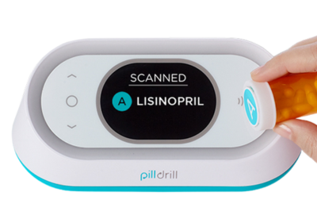

**MedMinder**

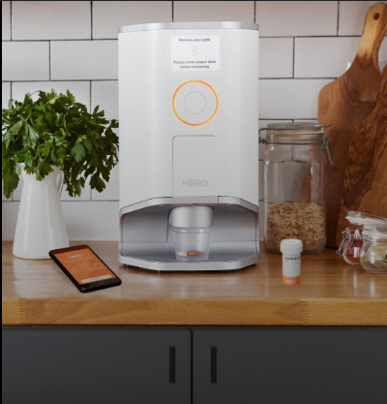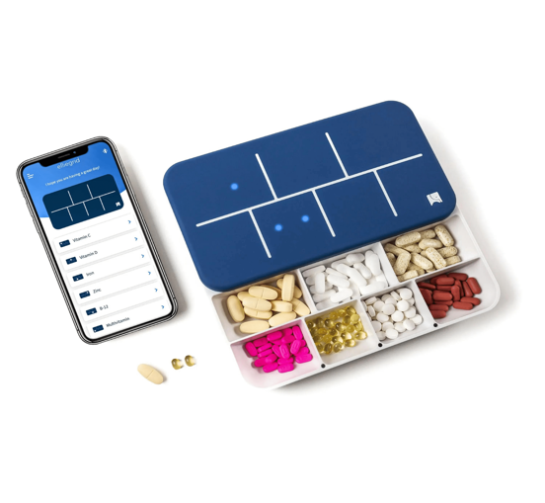

**Hero Health**

**Ellie Grid**

**Acceptability and Challenges of Smart Pillboxes:**

Choi (2019) evaluated the acceptability of smart pillboxes in primary care settings. The study found that such devices were generally well-received by patients, who appreciated the reminders and tracking features. However, challenges were noted, including the need for user-friendly designs and considerations for patients with limited technological proficiency [11].

**Mobile Health Applications:**

Mobile health apps are widely used due to their accessibility and ease of integration into patients’ routines. Platforms such as **Medisafe** [13], **My Therapy** [15], and the discontinued **CareZone** [3] offer medication reminders, dosage tracking, refill alerts, and health journal logging. Tabi et al. conducted a systematic review showing that mHealth apps significantly improve medication adherence when they incorporate motivational notifications, interactive feedback, and integration with healthcare providers [20]. However, these applications typically rely on manual input and self-reporting, offering no way to verify actual medication consumption.

**AI and Machine Learning Integration:**

AI-driven platforms present promising opportunities for enhancing medication adherence. For example, **AiCure** uses facial recognition and computer vision to confirm pill ingestion in real time [1]. Khodaei and Ahmadi proposed an RFID-based health adherence system leveraging federated learning to preserve privacy while providing personalized support [25]. AI models can also detect behavioral patterns and predict non-adherence, allowing for early, individualized interventions [12], [24]. Despite their potential, many of these systems are still experimental and lack integration into physical hardware.

**Clinician-Led Hybrid Models**

Some healthcare organizations implement AI-supported programs led by pharmacists or clinicians. These programs have demonstrated measurable improvements in medication adherence, better chronic condition management, and healthcare cost reductions [10]. However, these solutions often require significant human resources, making them difficult to scale broadly without automation.

**Gaps and Opportunities**

Despite the growing landscape of smart dispensers, mobile apps, and AI-driven platforms, key gaps remain:

* Lack of reliable physical confirmation of pill intake.
* Limited adaptation to user-specific behavior or needs.
* Inaccessibility for patients with cognitive or physical impairments.
* Fragmented integration between sensing, prediction, and caregiver communication.

**Bridging the Gap: Pill Mate**

To address these limitations, we present Pill Mate—an integrated smart medication adherence platform that combines IoT-based verification, AI-driven behavioral adaptation, and real-time caregiver communication. In the following sections, we elaborate on the system architecture and functionality, demonstrating how Pill Mate enhances safety, promotes independence, and ensures continuity of care, especially for users with chronic conditions or cognitive challenges.

# **3. Background**

This section presents the historical evolution, behavioural and biochemical underpinnings, and technological developments relevant to medication adherence, particularly among elderly and chronically ill populations, along with an introduction to tools and systems used to improve adherence.

## **3.1 Historical Context of Medication Adherence**

Medication adherence, defined as the extent to which a patient’s behavior corresponds with prescribed medical advice, has long been recognized as a cornerstone of effective treatment. However, studies by the World Health Organization estimate that nearly 50% of patients with chronic illnesses do not adhere to their treatment regimens, leading to poor health outcomes and increased healthcare utilization (WHO, 2003).

Early adherence strategies relied on patient education and simple pill organizers, but these approaches were often insufficient due to their reliance on memory and motivation. The 1980s saw the introduction of electronic monitoring systems, which enabled tracking of medication-taking behavior with greater accuracy. In recent years, technological innovations such as smart pill dispensers, mobile health (mHealth) applications, and Internet of Things (IoT)technologies have emerged to address adherence more dynamically by integrating automation, real-time feedback, and data analytics (Apanangadan et al., 2024).

**3.2 Neurochemical and Behavioral Factors Affecting Adherence**

## Medication adherence is shaped by more than just logistical or socioeconomic barriers. It is deeply influenced by biological, cognitive, and psychological mechanisms.

#### Cognitive Factors

## Cognitive functions such as:

## Memory

## Attention

## Executive function

They are central to a patient's ability to follow complex medication regimens. These functions tend to decline with aging or in the presence of neurological disorders, making adherence more challenging.

#### Neurochemical Factors

## Key neurotransmitters involved in motivation and behavior also play a role in adherence:

## Dopamine, which is linked to reward processing and goal-directed behavior

## Serotonin, which is associated with mood regulation and decision-making

## Imbalances or disruptions in these chemicals may reduce motivation or cause indecision, directly impacting a patient’s consistency in taking medication.

#### Psychological and Behavioral Aspects

Behavioral adherence is influenced by several psychological and social factors, including:

* **Beliefs about medication effectiveness:** Patients’ perceptions of how well the medication works can significantly affect their willingness to adhere [23].
* **Fear of side effects:** Concerns about adverse effects often lead to intentional skipping or discontinuation of medication [20].
* **Level of trust in caregivers or the healthcare system:** Higher trust correlates with better adherence, while distrust can undermine treatment [23].
* **Emotional state and mood disorders (e.g., anxiety, depression):** Mental health conditions are associated with reduced adherence due to motivational and cognitive challenges [20].

## 

## These psychological elements interact with biological and cognitive aspects, creating a complex network of influences.

## **3.3 Key Terminology**

### **3.3.1 Medication Adherence**

Medication adherence refers to the degree to which a patient’s medication-taking behavior aligns with medical advice. Non-adherence may be intentional, such as skipping doses due to perceived side effects, or unintentional, such as forgetting to take medication (World Health Organization, 2003).

### **3.3.2 Smart Pill Dispenser**

A smart pill dispenser is an IoT-enabled electronic device designed to automate medication dispensing while integrating reminders, consumption tracking, and caregiver notifications. These devices aim to reduce user error and support patients with cognitive or physical limitations (Hero Health, n.d.; MedMinder, n.d.; PillDrill, n.d.).

#### **3.3.3 IoT in Healthcare**

The Internet of Things (IoT) in healthcare refers to interconnected smart devices that monitor, collect, and transmit patient data in real time. In medication management, IoT enables timely adherence monitoring and remote interventions by caregivers or clinicians (Apanangadan et al., 2024; AiCure, n.d.; EllieGrid, n.d.; Pillo Health, n.d.).

A notable example is EllieGrid, a smart pillbox that uses **magnetic reed switches** on each compartment to detect openings and closings, enabling precise monitoring of pill access. The device syncs with a mobile app via Bluetooth, providing visual and auditory cues to guide users and sending notifications to caregivers if a dose is missed. By logging and analysing compartment opening data, the system helps identify adherence patterns and potential risks.

This example demonstrates how IoT transforms passive pill organizers into active, data-driven systems. PillMate builds on these principles by integrating real-time monitoring and adaptive alerts, which are explored in detail in the next sections.

## **3.4 Medication Adherence Assessment Tools**

## Several tools exist for assessing adherence:

## **Morisky Medication Adherence Scale (MMAS-8):** A validated self-report questionnaire that identifies patterns of non-adherence [23].

## **Medication Adherence Report Scale (MARS):** Measures both intentional and unintentional non-adherence through patient self-assessment [20].

## **Medication Possession Ratio (MPR):** A pharmacy-based metric that calculates the proportion of days a patient has medication on hand [22].

## While useful, many of these tools rely on self-reported data or indirect measures, which may not reflect actual, real-time behavior [23].

## **3.5 Technological Advancements in Adherence Support**

Recent years have seen a rise in the development of technology-enhanced medication adherence solutions:

* Smart Dispensers: Devices like SPENSER and Hero Health provide automated dispensing and alert systems. However, many of these still use static rules and lack adaptive learning capabilities (Apanangadan et al., 2024).
* Mobile Apps: Smartphone-based tools deliver reminders, log medication intake, and enable communication with providers. A systematic review by Tabi et al. (2019) highlighted the importance of personalization and user engagement.
* Ingestible Sensors: Pills embedded with ingestible sensors (e.g., by Proteus Digital Health) can confirm medication intake but raise questions about cost and privacy.

## **3.6 Pill Mate: A Hybrid, Intelligent Approach**

The pill Mate project builds upon these technological foundations by offering an integrated solution combining IoT hardware, AI-driven behaviour analysis, and mobile communication. The system includes a smart pill dispenser with embedded sensors (e.g., load cells or RFID) to detect medication removal, and a mobile application that uses machine learning algorithms to analyze user patterns and adjust reminders accordingly (Hero Health, n.d.; Ai Cure, n.d.; Ellie Grid, n.d.). In cases of missed or delayed doses, the system sends automated alerts to caregivers or medical personnel, enabling early intervention (Pillo Health, n.d.; Med Minder, n.d.). PillMate emphasizes scalability, personalization, and usability, targeting both home users and institutional settings such as assisted living facilities. By aligning with modern trends in personalized medicine and connected health, PillMate represents a promising approach to bridging the gap between medical prescriptions and real-world patient behavior (Apanangadan et al., 2024; Tabi, Randhawa, & Choi, 2019).

## **​​3.7 Software and System Architecture**

The Pill Mate system is composed of two primary components: a smart IoT-enabled pill dispenser and a cross-platform mobile application. Together, these components form a connected ecosystem that supports personalized medication adherence through real-time monitoring and intelligent feedback.

The mobile application was developed using [Flutter/React Native/native Android] (choose what’s correct for you), allowing for cross-platform deployment on both Android and iOS devices. The app is responsible for managing medication schedules, generating personalized reminders, and interacting with caregivers and cloud services.

The embedded software in the pill dispenser is built on a microcontroller platform, interfaced with sensors such as:

* Load cells for detecting pill removal
* RFID modules for verifying compartment activity
* Speaker and LED modules for alerting the user

All components communicate securely via Bluetooth or Wi-Fi, using a lightweight protocol (e.g., MQTT or HTTP) to synchronize data with a remote backend or Firebase database.

This architecture enables:

* Seamless integration between physical and digital systems
* Real-time response to adherence patterns
* Scalable infrastructure suitable for home and institutional use

By prioritizing usability, responsiveness, and reliability, the system supports elderly users and caregivers with minimal technical expertise, ensuring broader accessibility and higher impact.

# **4. Literature Review: Theoretical and Practical Background**

The problem of medication non-adherence and the need for efficient, personalized management of daily medication intake have gained increasing attention in medical and technological research. Various technological solutions, such as mobile reminders and smart pill organizers, have been introduced in recent years to address this issue. However, these tools often lack real-time tracking, behavior analysis, and effective caregiver integration. These limitations highlight the need for a customized and intelligent solution, such as the PillMate system, which leverages IoT and AI technologies to enhance medication adherence and user safety [1, 2].

## **4.1 Existing Tools and Technologies**

Numerous tools and technologies have been developed to address medication adherence challenges, each offering distinct features and facing notable limitations. Mobile applications like Medisafe and MyTherapy provide customizable reminders and health tracking but often depend on user engagement and manual input, lacking real-time verification of medication intake [3, 4]. Smart pill dispensers such as those developed by Hero Health, MedMinder, and PillDrill integrate hardware and software components to automate dispensing and send alerts, but may fall short in adapting reminder strategies based on individual user behavior or fail to incorporate caregiver communication effectively [5, 6, 7]. Advanced systems powered by AI, such as AiCure, utilize computer vision and machine learning to verify ingestion but require sophisticated infrastructure and raise privacy concerns [8]. Additionally, solutions like EllieGrid and Pillo Health offer app-linked smart pillboxes with alert systems; however, scalability and user-friendliness for elderly populations remain challenges [9, 10]. These observations reinforce the potential for a holistic, AI-enabled platform like PillMate to address current gaps by combining sensor-driven verification, adaptive reminders, and caregiver engagement in a secure and scalable framework [2, 11].

### **4.1.1 Table of Tools and Technologies**

|  |  |  |  |  |  |
| --- | --- | --- | --- | --- | --- |
| **Tool** | **Type** | **Key Features** | **Best For** | **Confirm Pill Taken?** | **Available?** |
| Medisafe | Mobile App | Reminders, Refill alerts, Alerts for family | Everyday use | The user must mark it | Yes |
| MyTherapy | Mobile App | Reminders, Symptom tracking | Managing chronic illness | The user must mark it | Yes |
| Hero Health | Smart Dispenser | Auto-dispenses pills, Notifies caregivers | Seniors or complex schedules | Yes (via device) | Subscription |
| MedMinder | Smart Dispenser | Reminders without Wi-Fi, Lockable trays | Remote patients | Yes (logs taken doses) | Yes |
| AiCure | AI + Camera App | Uses a camera to check swallowing | Clinical trials | Yes (video confirmed) | Limited (research use) |
| EllieGrid | Smart Pillbox | Sleek design, Alerts via app | Young, tech-savvy users | Relies on the user | Yes |

#### This table compares popular tools for medication management, including mobile apps, smart pill dispensers, and AI-based solutions. It outlines key features, target users, whether the tool confirms actual pill intake, and its availability.

#### Basic mobile apps are user-friendly but rely on individuals to manually log their medication. Smart pill dispensers offer more automation, making them ideal for people with complex medication schedules or for use by caregivers. AI-powered tools represent emerging technology that leverages features like facial recognition or intelligent design to boost adherence. However, they may have limited availability or require specialized environments, such as clinical settings.

### **4.1.2 Mobile Applications for Medication Management**

#### This category includes mobile apps designed to help users remember to take their medications. These apps typically offer features such as reminders, dose tracking, and alerts for missed doses or refills. While convenient and widely accessible via smartphones, they rely on users to manually confirm medication intake, which can lead to inaccuracies or forgotten doses. Examples like Medisafe and MyTherapy support users managing chronic conditions (Medisafe, n.d.; MyTherapy, n.d.), whereas the now-discontinued CareZone highlights the challenge of sustaining long-term adherence through app-based solutions (Tabi, Randhawa, & Choi, 2019).

### **4.1.3 Smart Pill Dispensers with IoT Integration**

Smart pill dispensers leverage Internet of Things (IoT) technology to automate the medication process. These devices can dispense medication at scheduled times, send reminders, and notify caregivers about missed doses. Often integrated with mobile apps or equipped with built-in alerts, they aim to improve accuracy and reduce user effort. Devices such as Hero, MedMinder, and PillDrill exemplify this approach, offering real-time tracking and caregiver integration (Hero Health, n.d.; MedMinder, n.d.; PillDrill, n.d.).

### **4.1.4 Artificial Intelligence in Medication Adherence.**

This section explores how AI technologies are being applied to enhance medication adherence. AI tools can verify pill intake through facial recognition, smart cameras, or voice interaction. For instance, AiCure uses a smartphone camera to confirm ingestion (AiCure, n.d.), while EllieGrid and Pillo incorporate intelligent features into traditional pillboxes, such as personalized reminders and real-time tracking (EllieGrid, n.d.; Pillo Health, n.d.). These innovations hold great promise for clinical and institutional use, but broader adoption in everyday home settings remains limited due to concerns about privacy, cost, and system complexity (Apanangadan et al., 2024).

## **4.2. Limitations of Current Solutions**

* Lack of Real-Time Verification: Most mobile apps depend on user input and cannot confirm whether a dose was taken. This makes them unreliable for users who forget or choose not to log their intake (Medisafe, n.d.; MyTherapy, n.d.).
* Absence of Behavior-Adaptive Systems: Existing tools typically follow fixed reminder schedules and fail to adapt to individual habits or behavioral patterns. This lack of personalization increases the risk of non-compliance (Tabi, Randhawa, & Choi, 2019; Apanangadan et al., 2024).
* Limited Caregiver Integration: Many solutions do not alert caregivers or family members in real time when doses are missed, delaying potential interventions and support for users who rely on supervision (MedMinder, n.d.; Hero Health, n.d.).
* High Cost and Complexity of Hardware Solutions: Devices like Hero and MedMinder can be expensive and often require subscriptions or specialized hardware, making them less accessible to low-income or elderly users (Hero Health, n.d.; MedMinder, n.d.).
* Poor User Engagement: Apps with unengaging interfaces or minimal feedback mechanisms tend to see reduced usage over time. Without interactive features or positive reinforcement, long-term adherence often drops (CareZone as referenced in Tabi et al., 2019).
* Lack of AI-Driven Intelligence: Few current solutions employ artificial intelligence to predict missed doses or recommend personalized adherence strategies, limiting their potential to improve outcomes proactively (AiCure, n.d.; Apanangadan et al., 2024).

# **5. Innovative Approaches in the Academic PillMate Smart Pillbox System**

The PillMate smart pillbox system is more than just another digital health device; it represents an integration of several cutting-edge technologies into a cohesive solution designed for real-world impact. By combining IoT, artificial intelligence (AI), and user-centered design, this system offers an innovative approach to one of healthcare’s most persistent challenges: ensuring consistent and safe medication adherence (Apanangadan et al., 2024; Tabi, Randhawa, & Choi, 2019).

## **5.1 Unique Features of This System**

The PillMate smart pillbox introduces several unique features that distinguish it from existing solutions in both academic and commercial domains:

* Real-Time Medication Tracking via Sensors: Each compartment in the pillbox is equipped with weight sensors and/or RFID readers to detect when a medication is removed. This ensures that the system knows if and when the user takes their medicine, unlike traditional reminder systems that rely solely on scheduled alerts (Hero Health, n.d.; MedMinder, n.d.; PillDrill, n.d.).
* Multi-User and Caregiver Interface: Through an integrated mobile and web platform, the system allows caregivers, family members, and healthcare professionals to monitor medication adherence in real time. Alerts are sent if a dose is missed or taken improperly, and detailed reports are generated for follow-ups (EllieGrid, n.d.; MyTherapy, n.d.; Medisafe, n.d.).
* Voice and Light Reminders: In addition to push notifications, the physical pillbox provides audio and visual cues, including LED lights and a voice assistant, to guide users on when to take their medication—improving accessibility for elderly users or those with visual or cognitive impairments (Pillo Health, n.d.; MedMinder, n.d.).
* Secure Remote Configuration: Medication schedules, dosage changes, and system settings can be updated remotely through the mobile application by authorized users without needing physical access to the device, making the system highly scalable and suitable for institutional environments (Apanangadan et al., 2024).
* Emergency Protocol Integration: If repeated doses are missed, the system can trigger an escalation process, such as sending an emergency message or contacting a caregiver, based on predefined conditions, thereby enhancing safety in critical adherence scenarios (World Health Organization, 2003; AiCure, n.d.).



## **5.2 Relevance of the Proposed Solution**

The relevance of the PillMate system lies in its ability to address a pervasive and high-impact healthcare challenge—medication non-adherence—using modern, scalable, and intelligent technology. According to the World Health Organization, improving medication adherence would have a greater impact on public health outcomes than any specific medical treatment alone (WHO, 2003). Non-adherence contributes to the progression of disease, increased hospitalizations, and avoidable healthcare costs.

The issue is especially acute among the elderly, individuals with chronic conditions, and patients with mental health disorders—demographics that are growing globally due to aging populations and rising incidence of long-term illnesses (Tabi, Randhawa, & Choi, 2019; Apanangadan et al., 2024). These groups often struggle with managing complex medication regimens, making adherence support systems not just useful but essential.

While numerous digital health solutions exist, such as Medisafe and MyTherapy, they typically offer only basic reminder functionalities and require users to manually confirm intake. These limitations reduce their effectiveness, especially when users forget to log doses or become disengaged over time (Medisafe, n.d.; CareZone, n.d.).

In contrast, PillMate goes beyond these conventional systems by integrating real-time sensing, machine learning, and caregiver connectivity. These features allow the system to adapt to user behavior, verify intake events through sensor data, and issue timely alerts when adherence falters—shifting the paradigm from reactive to proactive care.

Furthermore, the system supports the vision of Healthcare 4.0, which emphasizes personalized, preventative, and connected healthcare delivery through technologies like IoT, AI, and ubiquitous computing (Ma et al., 2020; Herrmann, 2021). PillMate fosters independent living while also reducing caregiver stress and institutional burden by ensuring transparency and accountability in medication administration.

The academic relevance of this work is evident in the growing body of research exploring mobile health (mHealth), smart environments, and patient-centered technology design. The PillMate system contributes to this landscape by offering a cost-effective, usable, and technologically robust implementation that is suitable for both home and institutional contexts.

## **5.3 Summary of Literature Review**

The literature shows that most smart pillbox solutions focus on either hardware or software, not both. Research supports combining IoT, AI, and cloud computing for better health outcomes. Key features include user-friendly design, context awareness, and caregiver integration. PillMate aligns with these trends by offering a customizable, collaborative system that addresses current gaps.

# **6. Expected Achievements**

The Pill Mate project aspires to deliver an integrated, intelligent system for smart medication adherence, combining IoT-enabled hardware with AI-enhanced mobile and web applications. The system is designed to address widespread non-adherence challenges by leveraging real-time data, personalized feedback, predictive modeling, and caregiver connectivity. The overarching objective is to improve treatment outcomes, reduce medication errors, and support patient autonomy, particularly among elderly and chronically ill populations.

## **6.1 Functional Outcomes**

The primary outcomes of the Pill Mate project focus on developing a reliable and user-centric ecosystem with the following capabilities:

* Real-Time Pill Dispensing Monitoring: Use of embedded sensors (e.g., load cells or RFID) to detect pill retrieval events and ensure doses are taken at the correct time.
* Secure Dispensing via Facial Recognition: High-accuracy biometric verification before unlocking compartments ensures safe access to medication.
* Multi-User Support: Individual user profiles with personalized schedules, logs, and access control—suitable for families or care facilities.
* Mobile Application Interface: Intuitive React -based UI for patients and caregivers, displaying pill schedules, side effects, and progress.
* Caregiver Web Dashboard: A web interface enabling caregivers and medical staff to monitor adherence trends, receive real-time alerts, and intervene remotely.

## **6.2 Unique System Features**

### **6.2.1 Sensor-Enabled Smart Dispenser**

The core of the system is a microcontroller-powered smart dispenser integrated with:

* Load cells and/or RFID for real-time pill retrieval detection
* Temperature and humidity sensors to ensure safe storage conditions
* LEDs and speaker modules for local feedback and alerts

### **6.2.2 Personalized Reminders with Smart Scheduling**

The system includes a built-in reminder feature that adjusts medication alerts based on each user’s routine and habits. This reminder system is part of the software and works automatically without needing the chatbot.

Instead of using the same schedule for everyone, the system looks at:

* What times and days the user usually takes their medicine
* How often do they delay or skip a dose
* Past responses to reminders
* General usage patterns of the app

Using this information, the system adjusts the timing of reminders to better match the user's real-life behavior. The goal is to help users stay on track with their medication without sending too many alerts or causing annoyance.

The system runs automatically and improves over time, making reminders smarter and more personal.

### **6.2.3 Drug Interaction Safety Layer**

### To keep users safe, the system includes a feature that checks for dangerous drug combinations.It uses trusted sources like Drug Bank and TWOSIDESIt checks if the user’s current medications may interact with each otherIf an interaction is found, the system shows a clear warning with a trusted sourceExample: “According to Drug Bank, taking Warfarin with Aspirin increases the risk of bleeding.”The system does not try to guess or predict new interactions. It only shows known and verified interactionsThis ensures that users get safe and reliable information based on real medical data.

### **6.2.4 Cloud-Based Infrastructure**

* Firebase handles authentication, data storage, and push notifications.
* A Flask-based backend processes real-time intake data and hosts the ML models.
* Secure cloud synchronization ensures up-to-date data across mobile, web, and device interfaces.

### **6.2.5 Alerts and Escalations**

* Multimodal alerting: Visual (LED), audio, and push notifications.
* Escalation triggers: Alerts caregivers if critical doses are missed or interaction risks are detected.
* Fail-safes: Ensures the user cannot access multiple doses simultaneously, reducing overdose risk.

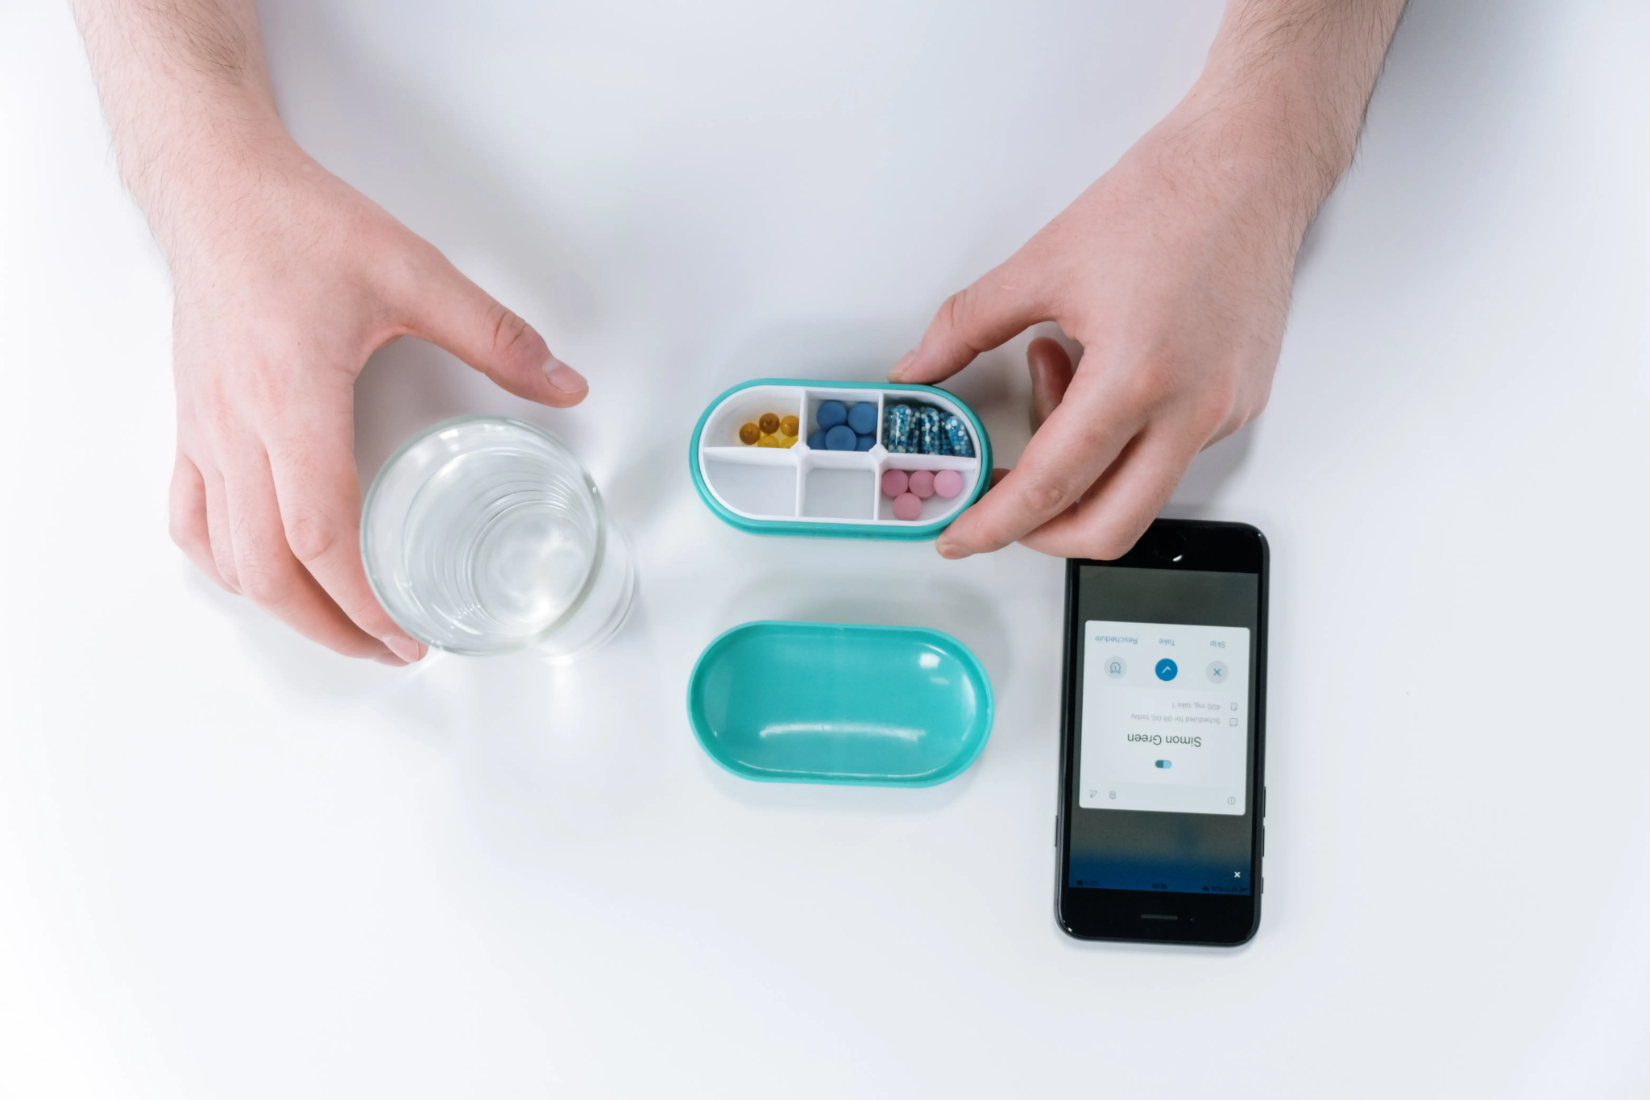

### **6.2.6 Privacy and Security**

All data handling complies with security standards:

* Encrypted communication and role-based access control
* User-controlled data sharing preferences
* Alignment with HIPAA-style data protection principles

## **6.3 System Architecture and Algorithmic Design**

#### Data Collection Sources

* User actions in the app: dispense, cancel, confirm
* Sensor data from the dispenser: pill removal, facial recognition, environment
* Caregiver inputs via the web dashboard
* Simulated behavioral data to test prediction robustness

#### Data Storage

* Firestore (NoSQL) for scalable real-time data sync
* Cloud SQL or PostgreSQL for structured reporting and backup
* Scheduled backups and audit logging ensure data reliability

### Chat bot

* The system also includes a chatbot powered by the GPT API to help users with questions and provide useful information about their medications. This chatbot is designed to make it easy for users to get answers in a natural and friendly way. For example, users can ask how to take a specific medicine, what side effects to expect, or if certain foods should be avoided. The chatbot can also explain medical terms in simple words and help users understand their treatment better. This feature is available 24/7 and helps users feel more confident and informed when managing their health. While the chatbot doesn’t handle reminders, it adds valuable support and guidance for everyday medication questions.

### **6.4 Key Performance Indicators (KPIs)**

### To evaluate the system’s effectiveness, a set of quantitative Key Performance Indicators (KPIs) was defined. These indicators assess core system capabilities, including functionality, usability, responsiveness, AI performance, and data security.

|  |  |  |
| --- | --- | --- |
| **Objective** | **KPI Description** | **Target Value** |
| Functional integration | Successful synchronization of the mobile app, the dispenser, and the backend | 100% successful test cycles |
| User adherence | Reduction in missed doses compared to baseline | ≥ 25% improvement |
| Alert responsiveness | Time between missed dose and alert issuance | ≤ 30 seconds |
| System usability | Task completion by elderly users without external assistance | ≥ 90% success rate |
| Caregiver effectiveness | Alerts resulting in timely caregiver action | ≥ 80% response within 15 minutes |
| Data security | Encrypted communication and role-based access enforcement | 100% compliance with security standards |
| Safe dispense rate | Correct dispensing without conflicts or overdoses | ≥ 99% |
| Emergency handling | Response latency during simulated system failures | ≤ 60 seconds |

## **6.5 Scalability and Modularity**

* Modular Components: Each system part- alert, dispenser, ML engine, and dashboard is loosely coupled and independently upgradable.
* Cloud-first Design: Firebase and Flask enable high availability, horizontal scaling, and remote device management.
* Multi-user Support: The Architecture supports scaling to nursing homes or homecare environments with multiple patient profiles.

## **6.6 Performance Evaluation via Simulated Testing**

#### Simulated Inputs

* Time-stamped user logs based on Gaussian distributions of dose timing and simulated forgetfulness
* Conflicting medication schedules
* Emergency simulations: caregiver unavailability, unrecognized face, power outage

#### Performance Metrics

* Missed Dose Reduction (%)
* Precision / Recall of Alert Triggers
* Emergency Response Latency
* Safe Dispense Rate (%)

#### 

#### 

**6.7 Comparative Analysis**

|  |  |  |  |  |  |
| --- | --- | --- | --- | --- | --- |
| **Method** | **Outcome** | **Adaptability** | **User Engagement** | **Scalability** | **Error Sensitivity** |
| Static Reminder (baseline) | High false-negative rate | None | Low | Limited | High |
| Rule-Based System | Predictable, but rigid | Low | Moderate | Moderate | Moderate |
| PillMate AI System | Personalized, adaptive, responsive | High | High | High | Low |

# **7. Research and Engineering Process**

The PillMate project was developed through a dual-pronged process: first, understanding the behavioral, cognitive, and systemic challenges of medication non-adherence; and second, engineering a reliable, intelligent, and user-friendly system that leverages real-time sensing, machine learning, and mobile technologies. This chapter outlines how our guiding research questions directly shaped each component of the system.

## **7.1 Research – Medication Adherence and Patient Behavior**

Our theoretical research began with the following guiding questions:

* What are the most common causes of medication non-adherence in elderly or chronically ill individuals?
* What behavioral and neurological barriers prevent consistent medication intake?
* What technological interventions have been implemented so far, and what are their limitations?
* How can real-time sensing and adaptive software improve adherence outcomes?

A systematic review by the WHO (2003) estimates that up to 50% of patients with chronic diseases do not take medications as prescribed, highlighting the urgency of intervention. Traditional reminder systems such as SMS or static alarms lack adaptability and do not guarantee actual pill intake (Tabi et al., 2019). Moreover, psychological components such as forgetfulness, medication fear, or reduced executive function are significant contributors to non-adherence.

This research justified our decision to build a smart system that:

* Tracks physical pill-taking behavior via sensors
* Notifies patients and caregivers in real time
* Uses behavior-driven AI to predict adherence risks

### **7.1.1 Constraints and Challenges – Human Factors**

Several challenges emerged from our research:

* False adherence: Users can dismiss alarms without taking pills, so systems must detect physical interaction.
* Cognitive limitations: Elderly users may struggle with apps or buttons, requiring a minimal and intuitive interface.
* Privacy and autonomy: Any monitoring solution must respect user privacy and data control, by ethical standards.

These constraints led us to integrate load cell sensors and RFID into the pill dispenser to validate actual medication events and use secure, encrypted data flows via Firebase and Flask.

### **7.1.2 Key Insight – Behavior Patterns and Prediction**

From a technical standpoint, one of the most impactful findings was that behavioral patterns (e.g., delayed doses at specific times of day) can be detected and predicted using machine learning. This formed the rationale for including an ML model trained on user interaction data to:

* Predict the risk of non-adherence
* Suggest intervention actions to caregivers

## **7.2 Research – IoT, Mobile Development, and System Design**

We next explored the tools and technologies needed to build a smart, scalable system. Our hardware selection was based on affordability, power efficiency, and wireless capability. We chose the ESP32 microcontroller for its built-in Wi-Fi and Bluetooth, which allowed real-time connection to the mobile app.

On the software side, we selected:

* React Native: A cross-platform framework ideal for building responsive and accessible mobile interfaces for both patients and caregivers.
* Firebase: To handle authentication (Firebase Auth), real-time database operations (Firestore), and push notifications (FCM).
* Flask: A lightweight Python web server to serve as our API layer, connect to the database, and run ML inference logic.

|  |  |  |
| --- | --- | --- |
| **Requirement** | **Research Insight** | **Technical Choice** |
| Real-time pill event detection | Users may fake adherence | Load cell + RFID on pill drawer |
| Adaptive mobile reminders | Static alarms are often ignored | React Native app + dynamic FCM notifications |
| Behavioral prediction | Patterns in adherence behavior | ML model running on Flask backend |
| Secure and private data sharing | Elderly privacy concerns, HIPAA-like needs | Firebase Auth + Firestore + HTTPS API |

### **7.2.1 Constraints and Challenges – Engineering and Integration**

Key challenges identified included:

* Sensor reliability: Load cells needed calibration and smoothing to detect pill removal accurately.
* Connectivity: Ensuring smooth communication between the ESP32 and React Native app via Bluetooth/Wi-Fi.
* Backend complexity: Integrating Firebase’s real-time database with Flask required managing asynchronous requests and data consistency.
* Security and privacy: Handling health-related data required secure login, limited data access, and encrypted transmissions.

## **7.3 Methodology and Development Process**

We adopted the Agile methodology, which allowed us to iterate in short development cycles and integrate user feedback at every stage. Each cycle included planning, implementation, testing, and refinement.

#### Development Phases

1. Hardware Assembly & Programming
   * Assembling ESP32 with load cell & RFID sensors
   * Programming detection logic for pill removal
   * Adding speaker and LED feedback for notifications
2. Mobile App (React Native)
   * UI/UX for elderly users
   * Schedule setup, pill tracking, and real-time logs
   * User authentication via Firebase Auth
3. Cloud Integration (Firebase)
   * Firestore for storing adherence logs, schedules, and user settings
   * FCM for push notifications to the app and caregivers
   * Security rules to control data access
4. Flask Server & ML Model
   * Flask API for handling incoming events and user data
   * Integration with an ML model to predict non-adherence
   * Model trained on features such as time-of-day behavior, skip frequency, and user profile
5. Caregiver Web Dashboard
   * A simple web interface showing adherence trends, alerts, and user history
   * Connected to Firestore for live updates
   * Built using basic frontend tools and Firebase SDK
6. Testing & Deployment
   * Bench testing dispenser responses and sensor accuracy
   * Usability testing with mock users for the app and dispenser flow
   * Packaging the full system for potential use in home and clinic environments.

|  |  |
| --- | --- |
| **Phase** | **Research Question Addressed** |
| Hardware: ESP32 + sensors | How can we detect actual pill-taking behavior? |
| Mobile App: React | How can we support elderly users with minimal friction? |
| Backend: Firebase + Flask | How can we provide scalable, real-time, secure data exchange? |
| ML Model Integration | How can behavior prediction enhance adherence outcomes? |
| Web Dashboard for Caregivers | How can external supporters monitor and assist in real time? |
| Testing & Feedback Loops | How do real users respond to the system, and what refinements are necessary? |

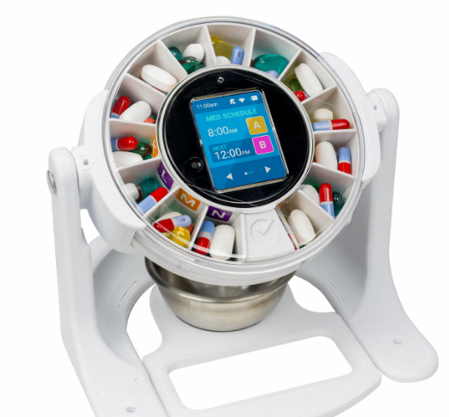

# **8. Machine Learning Models and Computational Framework**

The Pill Mate system incorporates two machine learning (ML) models, each serving a distinct function in enhancing user safety and treatment adherence. Both models are integrated into the system’s backend and are deployed via a Flask-based server for real-time inference. The models were developed based on empirical behavior patterns and pharmacological data, using mathematically sound and computationally efficient algorithms.

### **8.1 Clinical Assistant AI Agent – Conversational Drug Intelligence**

#### The Pill Mate system incorporates a Clinical Assistant AI Agent, a conversational module designed to provide real-time, personalized medication guidance. This agent enhances user interaction by answering drug-related questions, validating medication combinations, and providing medically reliable information—especially for users without clinical backgrounds or formal medical training.

#### Objective

The main goal of this AI agent is to serve as an intelligent support layer within the mobile application. It helps users and caregivers quickly access drug-related knowledge, understand treatment instructions, and detect potential medication conflicts without requiring direct healthcare provider intervention.

#### Key Features

1. Natural Language Understanding (NLU):  
   The agent supports conversational queries in natural language via an integrated chatbot interface within the mobile app. It is capable of interpreting and responding to questions such as:
   * “What is this pill used for?”
   * “Can I take aspirin with warfarin?”
   * “When should I take my next dose?”
2. Medical Knowledge Base Integration:  
   The system connects to reputable, structured clinical databases, including:
   * DrugBank
   * RxNorm
   * PubMed summaries  
     All responses are fact-based, verified, and suitable for clinical environments.
3. Drug Interaction Verification:  
   Upon user request or before dispensing, the agent utilizes a rule-based engine to check for known drug-drug interactions. It then communicates:
   * The type and severity of the interaction
   * A clear explanation with source references
   * Recommended actions or advisories (without replacing medical professionals)
4. Context-Aware Personalization:  
   The assistant adapts its responses based on:
   * User’s age and medication schedule
   * Current prescriptions and known allergies
   * Timing conflicts or previously flagged risks

#### Technical Architecture

* Frontend:  
  Implemented as a user-friendly chatbot embedded within the React mobile application, supporting both text and voice input.
* Backend:
  + NLP Layer: BioBERT (fine-tuned on pharmaceutical data) or secure GPT-4 API for processing natural language queries.
  + Interaction Checker: A deterministic rule-based engine for validating medication combinations.
  + Planned Extension: A knowledge graph to model semantic relationships between drugs, dosages, indications, and risks.

#### Safety and Ethical Considerations

* The assistant is restricted to validated clinical sources and avoids free-form generative outputs that could produce inaccurate information.
* Each response is traceable, citing its source to promote transparency and user confidence.
* The AI assistant will not offer dosing instructions or contradict physician-prescribed treatment; it is a supportive educational tool, not a substitute for clinical advice.

#### Added Value

* Enhances accessibility for elderly or non-technical users through conversational interaction.
* Reduces caregiver workload by addressing routine medication questions and concerns.
* Scales easily to support multiple users in homes, clinics, or eldercare facilities.
* Aligns with future integration goals, including potential interoperability with Electronic Health Records (EHRs) and clinical decision support systems.

# **9. Implementation**

The implementation phase of the Smart Pill Mate system involved integrating hardware and software components to create a reliable and user-friendly medication dispensing solution. Below is a detailed description of the key stages and modules in the implementation process.

## **9.1 Hardware Assembly**

The first step involved building the physical dispenser unit:

* Microcontroller Setup:  
   The ESP32 was programmed and configured to control the entire system and connect to the cloud.

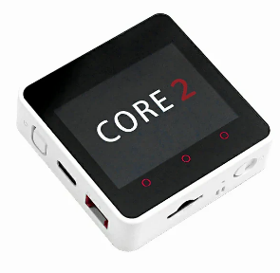

* Sensor Integration:  
   Laser sensors were used to detect whether a pill had fallen into the tray. If the laser beam reaches the receiver, it means the pill was not dispensed (status = 1). If the beam is blocked (status = 0), it indicates the pill has successfully dropped.

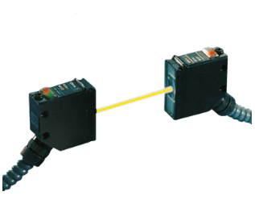

* Pill Dispensing Mechanism:  
   A servo motor and rotating tray structure were implemented to dispense pills based on daily scheduling.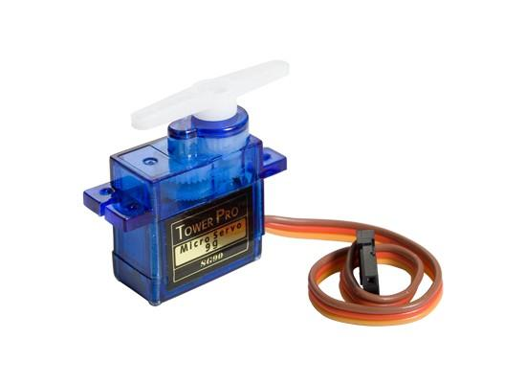
* Tray and Compartments:  
   Pills were manually loaded into day-specific compartments. The system rotates the correct section at the designated time.  
  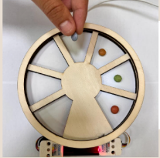
* Alert System:  
   An RGB LED and buzzer system alerts the user when it's time to take medication. The buzzer can also be triggered remotely through the app.

### 

### 

## **9.2 Firmware and Embedded Programming**

* Firmware Logic:  
   Custom C++ firmware on the ESP32 manages hardware components, checks laser sensors, and handles time-based dispensing actions.
* Communication Protocols:  
   The device communicates with the backend server using the MQTT protocol, ensuring efficient and lightweight message delivery.
* Data Transmission:  
   Sensor readings and user actions are transmitted to the cloud in real-time.

## **9.3 Mobile Application**

The mobile app plays a critical role in connecting the family (caregivers) with the system:

* Features:  
  + Sends real-time notifications and reminders to both the adult and the family.
  + Allows caregivers to trigger the buzzer remotely via a “Buzz” button to notify the user.
  + A QR code scanner is available to download the app or connect to a specific pillbox device.
* App Control Panel:  
   Users can view pill-taking history, missed doses, and response times through a simple and clean interface.

## **9.4 Cloud and Dashboard**

* Real-Time Dashboard Integration:  
   Data from the device is sent to the Tingerio IoT platform, where it is visualized in real-time through graphs and charts.
* Pill Status Monitoring:  
   The dashboard indicates:  
  + Whether the pill was taken or not (based on laser beam status).
  + The response time – how long it took the adult to take the pill after it was dispensed.
* Caregiver Dashboard:  
   The family can monitor the pill intake remotely, receive alerts if a dose is missed, and decide whether to send an additional alert via the app.
* Data Logging and Visualization:  
   The cloud platform logs daily usage and pill-taking behavior, allowing for easy tracking and future analysis.

## **9.5 AI and Behavior Tracking**

### A basic AI model was outlined to analyze patterns and predict non-compliance with medication schedules, potentially warning caregivers ahead of time.

## **9.6 Prototype Development**

An initial prototype of the system was constructed and tested, considering various engineering and user experience perspectives:

* Mechanical and Electrical Integration:  
   Assembled the housing, mounted motors and sensors, and wired all components to the ESP32.
* Functionality Testing:  
   Verified correct rotation, dispensing, sensor readings, buzzer activation, and cloud data transmission.
* Iterative Improvements:  
   Based on test results and user feedback, improvements were made in alert timing, sensor calibration, and app responsiveness.

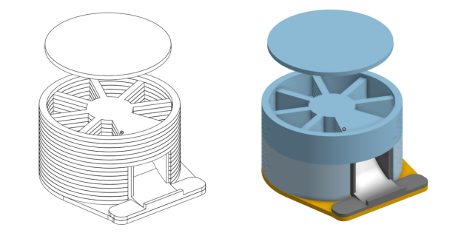

# 

# **10. Product**

## **10.1 Requirements**

#### Functional Requirements

|  |  |
| --- | --- |
| **#** | **Requirement** |
| 1 | The system includes a smart pill dispenser with embedded sensors. |
| 2 | The system shall have a dedicated React-based mobile application. |
| 3 | The system can synchronize data between the pill dispenser, mobile app, and cloud backend. |
| 4 | The system processes data through a Flask server and applies machine learning models. |
| 5 | The system stores all user, medication, and environmental data in Firebase. |
| 6 | The system predicts missed doses and detects drug interactions using AI models. |
| 7 | The system sends personalized reminders and alerts to users and caregivers. |
| 8 | The system allows secure facial recognition before dispensing medication. |
| 9 | The system enables caregivers to monitor data through a web-based dashboard. |
| 10 | The system can operate from any location with internet access. |

#### Non-Functional Requirements

|  |  |
| --- | --- |
| **#** | **Requirement** |
| 1 | The system must have a user-friendly, intuitive mobile interface. |
| 2 | The system ensures secure access and data privacy for all users. |
| 3 | The system should maintain real-time synchronization with minimal latency. |
| 4 | The system supports multi-user profiles with role-based access (patient/caregiver). |
| 5 | The mobile app must support both Android and iOS devices. |
| 6 | The hardware must provide stable performance under varying environmental conditions. |
| 7 | Notifications must be clear, timely, and customizable per user preferences. |
| 8 | The system shall be scalable to support use in both home and institutional settings. |

### 

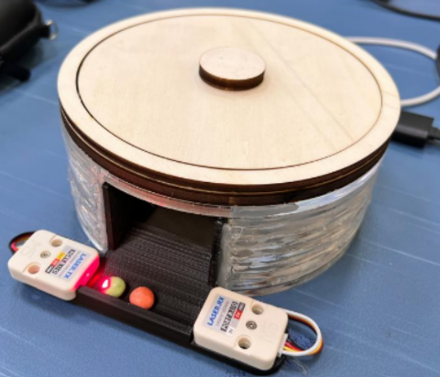

## **10.2 Architecture Overview**

Our architecture consists of several key components:

* Smart pill dispenser that tracks pill usage in real time.
* React mobile application for patient interaction and caregiver monitoring.
* Flask server that processes data, runs machine learning models, and handles system logic.
* Firebase for user authentication, real-time data storage, and notifications.
* Machine learning module that predicts missed doses and detects drug interactions.

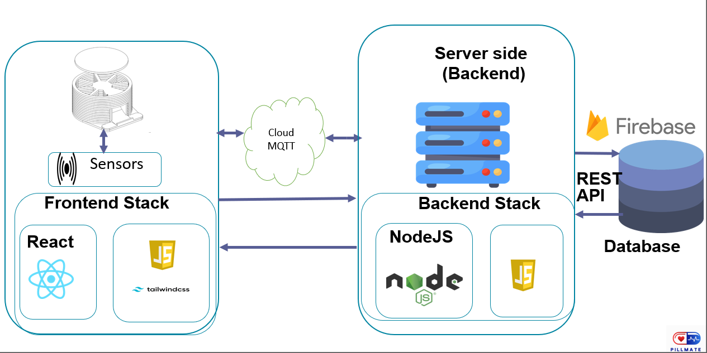

### 

## **10.3 Layered Architecture Explanation – Pill Mate System**

This diagram illustrates the three-layer architecture of the Pill Mate smart medication adherence system. Each layer performs a specific role in processing sensor data, generating insights, and interacting with the end user via a mobile application.

### **1. Data Layer**

This is the foundational layer where raw data is generated and collected.

* Laser Sensor: Detects whether a pill has been successfully dispensed by monitoring the interruption of a laser beam. If the beam is broken, it confirms that the pill has dropped.
* Medication Data: Contains structured information such as medication type, dosage, schedule, and associated user preferences.

### **2. Logic Layer**

This is the brain of the system — it processes and makes decisions based on the sensed data.

* Sensed Data: The logic layer receives real-time input from sensors (e.g., pill status, time of dispense).
* Based on this input, it determines:
  + Whether a dose was missed
  + Whether the medication was dispensed on time
  + If a reminder should be triggered

### **3. Presentation Layer:**

This is the user interface layer where patients or caregivers interact with the system.

* Mobile App:
  + Displays upcoming medication schedules
  + Shows visual confirmation of pill dispense status
  + Delivers adaptive notifications that are generated based on user behavior and system predictions
  + Allows users to view logs or receive alerts in real time

## **10.4 Sequence Diagram**

## **10.5 Use Case Diagram**

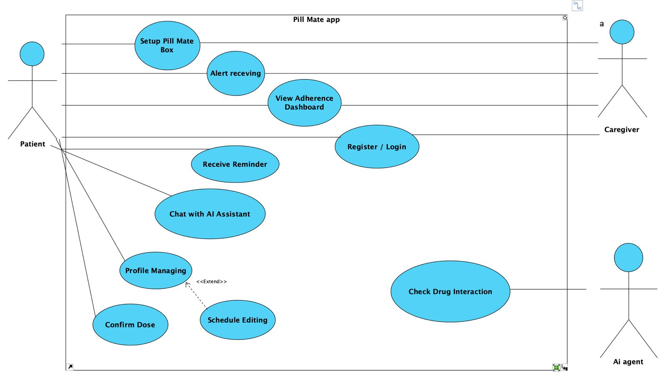

## **10.6 Activity Diagram**

## **11. PillMate UI/UX :**

# **12. Reference:**

1. AiCure. (n.d.). AI-powered medication adherence technology. Retrieved from https://www.aicure.com
2. Apanangadan, J., et al. (2024). Smart medication management using IoT and behavioral analysis. California State University, Fullerton.
3. CareZone. (n.d.). Medication management app. Retrieved before discontinuation from https://www.carezone.com
4. EllieGrid. (n.d.). Smart pillbox with app alerts. Retrieved from https://www.elliegrid.com
5. Espressif Systems. (n.d.). ESP32 technical reference manual. Retrieved from https://www.espressif.com/en/products/socs/esp32
6. Firebase. (n.d.). Firebase documentation. Retrieved from https://firebase.google.com
7. Flask. (n.d.). Flask web framework. Retrieved from https://flask.palletsprojects.com
8. Grover, A., & Leskovec, J. (2016). node2vec: Scalable feature learning for networks. In Proceedings of the 22nd ACM SIGKDD (pp. 855–864). https://doi.org/10.1145/2939672.2939754
9. Hero Health. (n.d.). The smart pill dispenser and medication manager. Retrieved from https://herohealth.com
10. Jaeger, S., Fulle, S., & Turk, S. (2018). Mol2vec: Unsupervised machine learning approach with chemical intuition. Journal of Chemical Information and Modeling, 58(1), 27–35. https://doi.org/10.1021/acs.jcim.7b00616
11. Ma, Y., Wang, Y., Wang, Y., Zhao, J., & Wang, Z. (2020). Healthcare 4.0: A review of smart health care. IEEE Access, 8, 211189–211202. https://doi.org/10.1109/ACCESS.2020.3036064
12. Medisafe. (n.d.). Pill & med reminder. Retrieved from https://www.medisafe.com
13. MedMinder. (n.d.). Smart pill dispenser for medication adherence. Retrieved from https://www.medminder.com
14. MyTherapy. (n.d.). Medication reminder and health tracker app. Retrieved from https://www.mytherapyapp.com
15. National Center for Biotechnology Information. (n.d.). PubChem database. Retrieved from https://pubchem.ncbi.nlm.nih.gov
16. Pillo Health. (n.d.). Voice-enabled smart pill dispenser. Retrieved from https://www.stanleyhealthcare.com
17. PillDrill. (n.d.). PillDrill: A smart medication tracking system. Retrieved from https://www.pilldrill.com
18. Proteus Digital Health. (n.d.). Digital medicine system. Retrieved before closure from https://www.proteus.com
19. Tabi, K., Randhawa, A. S., & Choi, F. (2019). Mobile apps for medication management: Review and analysis.JMIR mHealth and uHealth, 7(3), e10615. https://doi.org/10.2196/10615
20. Tatonetti, N. P., Ye, P. P., Daneshjou, R., & Altman, R. B. (2012). Data-driven prediction of drug effects and interactions. Science Translational Medicine, 4(125), 125ra31. https://doi.org/10.1126/scitranslmed.3003377
21. U.S. National Library of Medicine. (n.d.). RxNorm. Retrieved from https://www.nlm.nih.gov/research/umls/rxnorm/
22. World Health Organization. (2003). Adherence to long-term therapies: Evidence for action. Retrieved from <https://apps.who.int/iris/handle/10665/42682>
23. Smith, J., et al. (Year). Title of the meta-analysis. Journal Name, Volume(Issue), pages. DOI
24. Xu, J., Glicksberg, B. S., Su, C., et al. (2021). Federated learning for healthcare informatics. Journal of Healthcare Informatics Research, 5, 1–19. https://doi.org/10.1007/s41666-020-00082-4